3A - Measurement – Lesson 06
Units and Applications – Percentage Change

Name: _________________
- Why do we need to change amounts by a percentage?

- What is a price markup percentage?

- What are successive discounts?

- The corner shop marks up their prices by 85%. What are the retail prices for the following wholesale prices?

 | Wholesale | Retail
- Chocolate bar  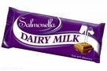 | $2.70 each | _______________
- Diet Coke  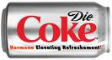 | $1.20 each | _______________
- Sponges  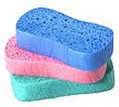 | $0.60 each | _______________

- A big supermarket (this is a true story) raised the price of $25 pedestal fans by 30% and then advertised a 30% discount on pedestal fans. What is the discount price?
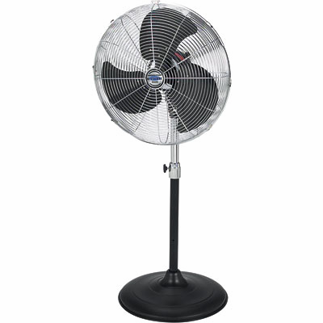
  - New Price = $25 x 1.30 x 0.70

= $ ______

  - Explain how the 1.30 in part a. was calculated.

  - Explain how the 0.70 in part a. was calculated.

- A car dealer is advertising a 15% fleet discount on its cars. If the car costs $35000 then what is the discounted price?


- An electrical retailer was offering a 20% general discount and an additional 10% trade discount. How much does the tradesman pay for a box of light bulbs that retail for $45.

